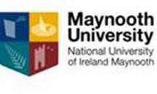

RETURN TO LEARNING

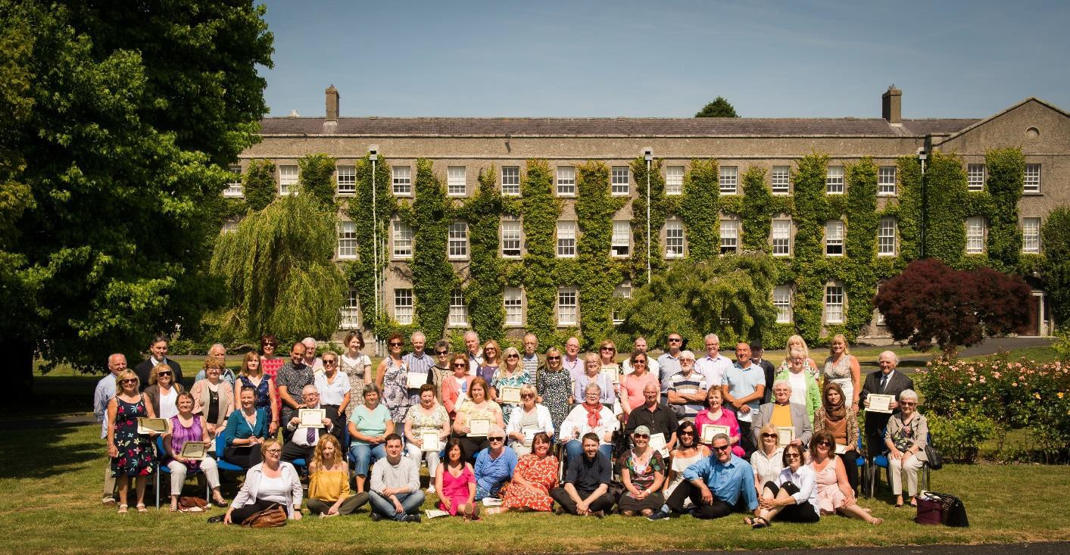

The Department of Adult and Community Education in Maynooth University takes a very different approach to teaching and learning than a lot of people will have encountered through their previous educational experiences. We value the knowledge that people bring with them from their everyday life and work with the student to bring them through the learning process. Mature students have life experience that can be very valuable. Anyone who has been working, either formally or as a full-time parent learns skills along the way. These could be budgeting, time management or conflict resolution. In addition, being older gives you a different way of approaching problems. All of this can be very useful when returning to education.
The Maynooth University Return to Learning certificate encompass Study Skills, Information and Communications Technology, Sociology and Local History. Students will sample subjects from the faculties of Arts and Social Sciences with lecturers who have years of experience in a wide range of academic settings. The Return to Learning course is aimed at people who have been out of formal education for a number of years and who want to experience a university education without having to commit to a full degree. Students who do progress onto undergraduate degrees, often excel in their chosen subjects due to the solid foundation of academic research and writing skills that the course had given them.
However, the Return to Learning course is more than just about acquiring the mechanical skills that people need to succeed in Higher Education. For many adults the initial step of crossing the threshold of a college can be very daunting. This can be enough to stop a person from even thinking about going to university. These initial qualms about being different to the majority of the students, being expected to know how to do things like use

the library or be competent on computers are dealt with over time and this element of personal development and confidence building is of central concern to us as adult educators. What the RTL does more than anything else is allows the student time to come to terms with university life and begin to understand who they are as a learner. This is another reason why RTL students who progress onto either the full-time or part-time degrees do so well, they have learned how to learn.
Classes are held on Monday and Wednesday mornings 10.00-12.30. Classes are small and the learning takes place within the classroom between the students and guided by our facilitators/lecturers. Our courses have been described as life changing, transformational and the best learning experience that people have ever had and the Return to Learning 2023 is shaping up to be on a par with the best of them. Classes will commence on 3rd October 2023.
Students who achieve a mark of 60% in their final overall grade will be accepted onto MH101 without interview. Students who opt for the Part-Time degrees for Adults BA Local Studies or BA Community studies (MH803) are eligible for Recognition of Prior Learning for this degree and may bypass Semester 1 Introduction to Programmes.

Part time students who are on courses at levels 6 to 10 on the framework of qualifications may be eligible to for the Student Assistance Fund (SAF) to help with the associated costs of attending a university course such as Travel, Childcare, Utilities, Materials etc.
mail
you should first consult: SAF Guidelines to see if you qualify and then e-
Once registered to this course

student.budget@mu.ie to make further enquiries.

