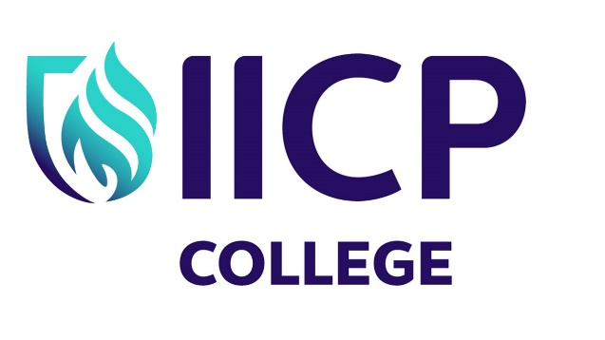

IICP Certificate in Counselling and Psychotherapeutic Studies

Summer Cert 2023 – Blended Option

QQI 20 credit certificate providing an excellent introduction to the field of counselling & psychotherapy.

Introduction
Our Certificate Programme is the perfect entry point for those considering a career in counselling and psychotherapy as it contains an excellent mix of theory, skills, and personal development. All IICP teaching staff are therapy practitioners, which means they put their teaching into a real-world context.

Programme Aims
Upon completion, learners should be able to:
- Demonstrate broad elementary knowledge of two main therapy approaches; Person Centred Therapy and Choice Theory/Reality Therapy.
- Describe the evolution of counselling and psychotherapy from historical to contemporary perspectives.
- Discuss mental illness and its treatment, including modern therapeutic approaches.
- Identify the scope and limitations of counselling and psychotherapy.
- Appreciate basic ethical considerations for working with others.
- Describe the essential components of a therapeutic relationship.
- Engage in simulated practice of basic counselling practice.
- Apply core counselling and psychotherapeutic skills in simulated practice.
- Participate in reflective exercises in one-to-one and group settings.
- Consider the role of the self in the therapeutic relationship.
- Recognise the limitations of one’s own knowledge, skills, and competencies; and
- Communicate effectively in academic and practice settings.

Entry Routes
This programme is suitable for those either working in the helping professions or interested in seeking to develop their awareness of what is involved in training as a counsellor/psychotherapist.
- A qualification recognised at level 5 on the National Framework of Qualifications (NFQ) such as the Leaving Certificate is required for entry onto this programme.
- Those with substantial life experience can also apply under our recognition of prior learning and experience policy.

Overview

The programme consists of three introductory modules in the subjects of Counselling Theory, Counselling Skills, and Personal Development. It is a highly interactive programme, delivered through a variety of teaching approaches such as lectures, group discussion, experiential work, individual exercises, and self-directed learning.

Student Benefits & Support

As our certificate is conferred at Level 6 on the National Framework of Qualifications (NFQ), it evidences the rigour required for a quality programme of learning. The dynamic mix of theory, skills, group work, practice and personal development ensures learners grow academically, professionally, personally, and interpersonally within frameworks that are on the cutting edge of best practice.

Validation of Award

This Certificate is a Special Purpose Award validated by QQI at level 6 on the NFQ. 20 ECTS Credits
Course Dates

Friday 9th June 2023 | 6:00pm - 10:00pm | Online
Saturday 10th June 2023 | 9:00am - 5:00pm | Onsite
Sunday 11th June 2023 | 9:00am - 5:00pm | Onsite
Friday 14th July 2023 | 6:00pm – 10:00pm | Online
Saturday 15th July 2023 | 9:00am – 5:00pm | Online
Sunday 16th July 2023 | 9:00am – 5:00pm | Online
Friday 11th August 2023 | 6:00pm – 10:00pm | Online
Saturday 12th August 2023 | 9:00am – 5:00pm | Onsite
Sunday 13th August 2023 | 9:00am - 5:00pm | Onsite
Course Cost
€1300 (Including €50 QQI Fee)
To apply:
For more details or to book online, please visit our website: https://www.iicp.ie/courses/certificate/
or contact the IICP Office
Phone: 087 905 5330
Email: admissions@iicp.ie

Triona Kearns
Director of Registry & Operations
Phone: 086 0499154

Marcella Finnerty
College President
Phone: 086 2609989

