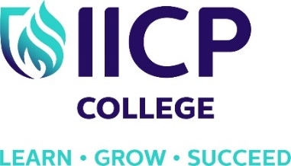
COUNSELLING AND PSYCHOTHERAPY TRAINING
QQI VALIDATED CERTIFICATE, DEGREE AND MASTERS
IACP ACCREDITED
‘FREE TASTER EVENING’ – 26th March 2019
Learn about a career in counselling and psychotherapy.
IICP College will hold a FREE Taster evening on Tuesday 26th of March 2019 from 7pm to 9pm. Come along to learn about our range of courses commencing in 2018. This informative evening will include sample lectures and an opportunity to have a question and answer session with our faculty members.
Courses
- Certificate Programme in Integrative Counselling and Psychotherapeutic Studies – level 6
- BA (Hons) in Counselling & Psychotherapy – level 8
- MA in Pluralistic Counselling & Psychotherapy – level 9
- MA in Integrative Child and Adolescent Psychotherapy – level 9
- CPD Short term continuous professional development courses
We start the evening with an introductory session to welcome everyone. A sample lecture will then be given on an introductory counselling and psychotherapy subject. This will be an interactive session with plenty of opportunity for participant involvement.
The evening will finish with a Q&A session when participants can ask our faculty any questions they have about our courses. The evening starts at 7.00pm sharp and continues until 9.00pm. Tea and coffee is available for those who arrive early!
To register for this event www.iicp.ie/taster or call the IICP office on 01-4664205. The event takes place in IICP College, Killinarden Enterprise Park, Killinarden, Dublin 24.

