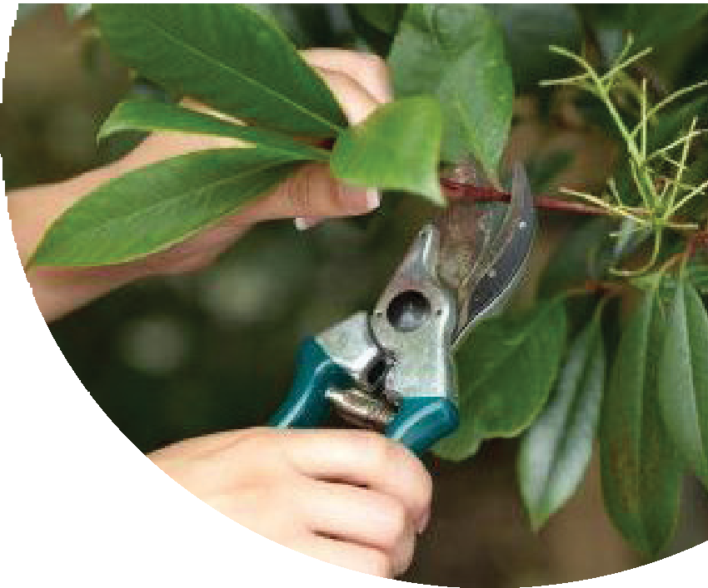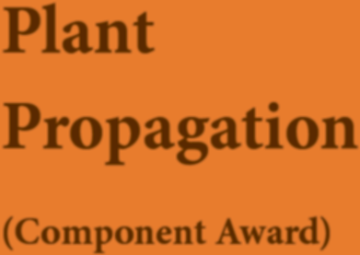Plant Propagation
(Component Award)

About the Course
The College of Amenity Horticulture at the National Botanic Gardens, Glasnevin and Teagasc Kildalton College, Piltown, Co. Kilkenny are offering a QQI Level 5 component award in Plant Propagation. This module will equip the learner with the knowledge and skills for the propagation of a wide range of plants. This course will lead to a minor award at NFQ Level 5 (5N2547).

Who should Apply?

This course is designed for anyone who wants to get involved in horticulture on a part-time basis while gaining an approved Level 5 minor award. It is also ideal for people who are currently working in other careers but who feel that they want to learn more about horticulture.

This module offers participants a chance to study at the National Botanic Gardens and Kildalton College.

By taking other Level 5 modules, students may be able to build towards a full major award of QQI Level 5 Certificate in Horticulture.

Further progression is also possible to level 6 and level 7 horticulture.

Module Content

On completion of the course, students will be able to:

- Outline the principles of plant propagation
- Outline the principles of division and layering
- Outline the principles of grafting
- Outline the principles of propagation by seed
- Describe the basic requirements for rooting cuttings
- Describe different systems used for cutting propagation
- Take a range of cuttings
- Prepare and sow seed
- Carry-out routine division and layering
- Carry-out bench grafting

Course Structure
The course will be offered in one 3 hour session per week over a 28-week period commencing in early September until mid-May at both colleges. Students will be required to take cuttings, prepare seed for sowing and carry out routine division and layering using safe work practices..
Application forms are available from:
Teagasc College of Amenity Horticulture, Botanic Gardens, Glasnevin, Dublin 9. Tel: 01-8040201 or Email: botanic.college@teagasc.ie
Teagasc Kildalton Agriculture & Horticulture College, Piltown, Co. Kilkenny Tel: 051-644400 or Email: kildalton.college@teagasc.ie
From the Teagasc website: www.teagasc.ie

Revision Date: May 2017

